Working with JSON in Programming Languages

🌟 What does this topic mean?
# Source: AI Source: Provided by: [Data Path: Persons Table -> ID Column: 1, Name_En Column: Motasem Essam] -> From: [ChatGPT] on [5/31/2026]
This topic explains how different programming languages read, write, convert, and use JSON data in real applications.
JSON is not a programming language — so every language has tools to work with it.

🔢 JSON in Programming Languages

1. 🧑‍💻 JSON in JavaScript
# Source: AI Source: Provided by: [Data Path: Persons Table -> ID Column: 1, Name_En Column: Motasem Essam] -> From: [ChatGPT] on [5/31/2026]
JavaScript has built-in support:
- JSON.parse()
- JSON.stringify()
Used in:
- APIs
- Web apps
- Fetch requests

1.1. 🔄 JSON Parsing (JSON → Object)
# Source: AI Source: Provided by: [Data Path: Persons Table -> ID Column: 1, Name_En Column: Motasem Essam] -> From: [ChatGPT] on [5/31/2026]
🌟 Meaning
Convert JSON text into a usable object in code.
📦 Example (JavaScript)
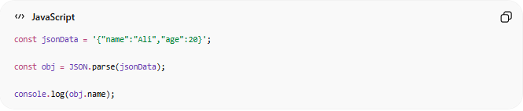
const jsonData = '{"name":"Ali","age":20}';
const obj = JSON.parse(jsonData);
console.log(obj.name);

1.2. 📤 JSON Stringify (Object → JSON)
# Source: AI Source: Provided by: [Data Path: Persons Table -> ID Column: 1, Name_En Column: Motasem Essam] -> From: [ChatGPT] on [5/31/2026]
🌟 Meaning
Convert an object into JSON format to send it.
📦 Example (JavaScript)
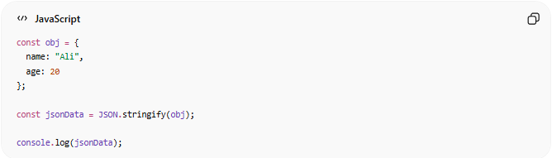
const obj = {
name: "Ali",
age: 20
};
const jsonData = JSON.stringify(obj);
console.log(jsonData);

2. 🐍 JSON in Python
# Source: AI Source: Provided by: [Data Path: Persons Table -> ID Column: 1, Name_En Column: Motasem Essam] -> From: [ChatGPT] on [5/31/2026]
Python uses the json module:
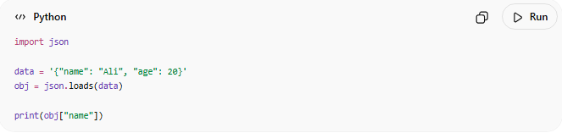
import json
data = '{"name": "Ali", "age": 20}'
obj = json.loads(data)
print(obj["name"])

3. 🐘 JSON in PHP
# Source: AI Source: Provided by: [Data Path: Persons Table -> ID Column: 1, Name_En Column: Motasem Essam] -> From: [ChatGPT] on [5/31/2026]
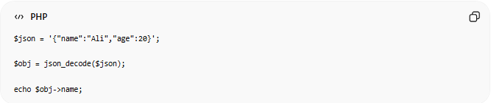
$json = '{"name":"Ali","age":20}';
$obj = json_decode($json);
echo $obj->name;

4. ☕ JSON in Java (Basic Idea)
# Source: AI Source: Provided by: [Data Path: Persons Table -> ID Column: 1, Name_En Column: Motasem Essam] -> From: [ChatGPT] on [5/31/2026]
- Uses libraries like Jackson or Gson
- Converts JSON ↔ Java objects

⚙️ JSON Conversion Process
# Source: AI Source: Provided by: [Data Path: Persons Table -> ID Column: 1, Name_En Column: Motasem Essam] -> From: [ChatGPT] on [5/31/2026]
JSON Text → Parsing → Object in Code
Object in Code → Stringify → JSON Text

📡 Why Programming Languages Use JSON
# Source: AI Source: Provided by: [Data Path: Persons Table -> ID Column: 1, Name_En Column: Motasem Essam] -> From: [ChatGPT] on [5/31/2026]
- Communicate with APIs
- Send data to servers
- Receive responses
- Store structured data

🧠 Simple Idea
# Source: AI Source: Provided by: [Data Path: Persons Table -> ID Column: 1, Name_En Column: Motasem Essam] -> From: [ChatGPT] on [5/31/2026]
Think of JSON like:
📦 A universal package format
Every programming language can:
- Open it 📥
- Read it 📖
- Pack it 📤

⚠️ Key Rule
# Source: AI Source: Provided by: [Data Path: Persons Table -> ID Column: 1, Name_En Column: Motasem Essam] -> From: [ChatGPT] on [5/31/2026]
Even though JSON looks simple, every language must:
- Parse it before using
- Convert it before sending

🧭 Summary
# Source: AI Source: Provided by: [Data Path: Persons Table -> ID Column: 1, Name_En Column: Motasem Essam] -> From: [ChatGPT] on [5/31/2026]
Working with JSON in programming languages means converting JSON into usable objects and converting objects back into JSON so data can be sent, received, and processed across different systems.

